# California State University, Fresno

# DEPARTMENT OF COMPUTER SCIENCE

|  |  |  |  |  |  |
| --- | --- | --- | --- | --- | --- |
| Class: | **Algorithms & Data Structures** | | | Semester: | **Fall 2021** |
|  | | | | | |
| Points |  | Document author: | **Javier Escareno** | | |
|  | Author’s email: | **Jayescareno22@mail.fresnostate.edu** | | |
| Laboratory number: | **Lab Section 1** | | |
|  | | | | | |

**1. Statement of Objectives**

Some of the elements used in this second lab was to use two different methods to calculate the 120th element in the Fibonacci sequence and time each method to compare and see which was faster for this task. The two different methods used in this Lab was calculating Fibonacci’s sequence using recursion and iteration to see which was faster. The major accomplishment of this lab was finding out which method was quicker in finder larger elements in the Fibonacci sequence.

**2. Experimental Procedure**

List the procedure used in this lab. Include how you approached the question and why.

Some of the procedures used in this lab were done in multiple steps. Step 1 was going over and reading multiple times the parameters given for the lab to make sure the assignment given, and the results required from the lab were understood completely. Once what was required was understood the next step was to start on coding Fibonacci’s sequence in the 2 different methods wanted with were recursively and iteratively.

**3. Analysis**

Discuss the experimental results. Include the screenshots of the results.

After getting the code set up and having both methods of finding Fibonacci’s sequence 120 element and timing both methods, we found that the recursive method was slightly faster than the iterative method. The time clocked for the recursive method was 0.026 seconds while the iterative method took 0.028 seconds.

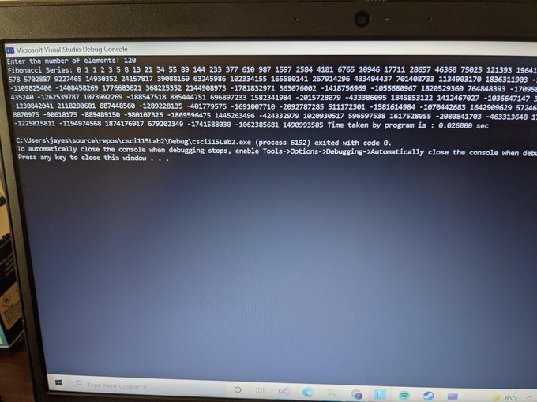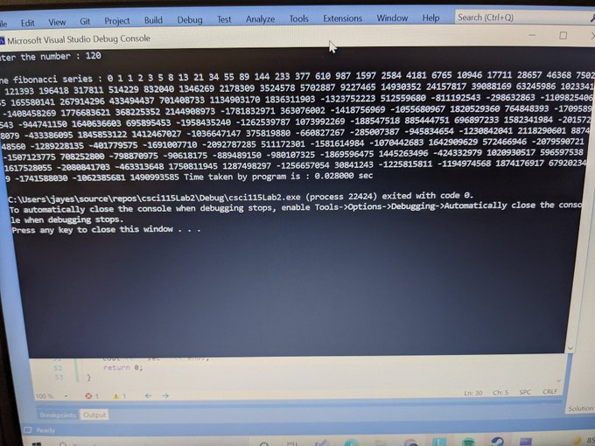

**4. Encountered Problems**

Some problems faced during this lab was getting the clock feature to work and time correctly how long each method took to find the 120th element in the Fibonacci’s sequence. After some research and tinkering the clock feature was able to be utilized in the program correctly and effectively.

**5. Conclusions**

Some of the things I learned in this lab was how to implement a clock feature into my code to get a sense of how quickly the code can compile. I also learned which method was faster to find the higher elements in a Fibonacci’s sequence.

**6. References**

Here is the reference used by me in the lab.

https://youtu.be/W7D3HGWoarg